LOCATION BASED MAP (ANDROID APP)

A MINI-PROJECT REPORT

*By*

Benita Rego

Nolita Rego

*Under the guidance of*

Prof. Dipali Koshti



DEPARTMENT OF COMPUTER ENGINEERING

FR. CONCEICAO RODRIGUES COLLEGE OF ENGINEERING

FR. AGNEL ASHRAM, BANDRA (W),

MUMBAI - 400 050.

UNIVERSITY OF MUMBAI

(2018 – 2019)

FR. CONCEICAO RODRIGUES COLLEGE OF ENGINEERING

FR. AGNEL ASHRAM, BANDRA (W),

MUMBAI - 400 050.



CERTIFICATE

This is to certify that the following students working on the project “Location Based Map” have satisfactorily completed the requirements of the project in fulfillment of the course S.E in Computer Engineering of the University of Mumbai during academic year 2018-2019 under the guidance of “Prof. Dipali Koshti”.

Submitted By: Benita Rego (8362)

Nolita Rego (8363)

|  |  |
| --- | --- |
| Prof.  Guide | Dr. B.S.Daga  Head of the Department |

________

Principal

|  |
| --- |
|  |
|  |

CERTIFICATE

This is to certify that the project synopsis entitled “Location Based Map” submitted by the following students is found to be satisfactory and the report has been approved as it satisfies the academic requirements in respect of mini-project work prescribed for the course.

BENITA REGO

NOLITA REGO

|  |  |
| --- | --- |
| Internal Examiner  (Signature)  Name:  Date: | External Examiner  (Signature)  Name:  Date: |

Seal of the Institute

DECLARATION OF THE STUDENT

We declare that this written submission represents our ideas in our own words and where others' ideas or words have been included, we have adequately cited and referenced the original sources.

We also declare that we have adhered to all principles of academic honesty and integrity and have not misrepresented or fabricated or falsified any idea / data / fact / source in my submission.

We understand that any violation of the above will be cause for disciplinary action by the Institute and can also evoke penal action from the sources which have thus not been properly cited or from whom proper permission has not been taken when needed.

Signature of the student Date:

(Benita Rego)

(8362)

Signature of the student Date:

(Nolita Rego)

(8363)

ABSTRACT

In this project, we have designed a simple model for Location Based Application Development. We have built an Android based Application that offers the Android user to search for his/her desired location on a Satellite Map using Location Based Services (LBS) that includes GPS, Internet/ Wifi enabled services. This application provides users with location based on the location they search. This includes searching locations like streets, buildings, cities, countries, etc. Location Based Services (LSB) serves to provide information to the android user based on their searched location using GPS on the android device. Mostly these services are provided online i.e. depends on the internet and thus have limited use in case of limited connectivity.

The system asks the user to enter a location he/she wants to search. Then it searches for the location and locates the place by zooming in that area. It also shows the nearby places around the location like hospitals, cafeteria, stores, etc.

Problem Statement

The study was designed to formulate a suitable framework, then build a proto-type based on it (as a proof-of-concept), for location based services for android devices, for developing an Android based Application on Location Based Services (Map) i.e. user can search desired location and see for nearby places on the map.

Table of Contents

Chapter 1: Introduction…........................................................................................................ 7

Chapter 2: Literature Review…............................................................................................... 8

2.1 Location Based Services………………………………………………………….8

2.2 Mobile-based Technologies*………………………………………………………*9

Chapter 3: Proposed System…................................................................................................10

3.1: Problem statement Analysis................................................................................. 10

3.2: Design and Methodology of proposed system…................................................. 11

Chapter 4: Hardware software requirements and Implementation........................................ 16

4.1: Results

4.2: Conclusion

References............................................................................................................................. 18

1. Introduction

Location Based Services are one of the most rapidly expanding fields of the mobile

communications sector, with a vast application range. A location based service is defined as

an information or entertainment service, accessible with mobile devices through a mobile

network and utilizing the ability to make use of the geographical position of the mobile

device. Location based services draw upon a combination of location acquisition technologies,

web services and spatial databases. They user’s knowledge of a mobile device’s location is to

offer value to the mobile subscriber or a third party.

Even though location based services are a hot topic, there are very few publicly available

frameworks for the rapid development of location based service applications. This thesis

attempts to address this shortfall and come up with a theoretical framework for the rapid

development of location based service applications. This is achieved by studying the

strengths and weaknesses of, the few, currently available frameworks. The study is further

complimented by carrying out a survey on the factors that influence the choice of a

framework by ICT professionals. The study then proposes an open framework for rapid

development of mobile location based service applications. It describes positioning prospects

using GSM networks, Wi-Fi networks and the GPS system. It further describes a location

aware application prototype built based on the proposed framework. This demonstrates that

building applications based on the proposed framework is feasible. The said prototype was

build based on the Rapid Application Development (RAD) methodology. The prototype as

currently build has room for improvement. Further work on the prototype could include

making it more interactive by letting users add their own points of interest on the map. The

prototype could also be extended to allow users add location based reminders. To allow users

to add data to the prototype would mean that the framework would also need to be extended

to include a web based database for storing this information centrally. This is achievable.

2. Review of Literature

* 1. Location Based Services

Location based services (LBS) draw upon a combination of location acquisition technologies,

Web services and spatial databases. LBS use knowledge of a mobile device’s location to offer value to the mobile subscriber or a third party. Various wireless location acquisition

technologies exist for implementing LBS. These include (Wang et al 2008):

■ Basic positioning methods such as:

■ Dead reckoning

■ Proximity sensing

■ Trilateration

■ Multi lateration

■ Triangulation

■ IEEE 802.il (Wi-Fi)

■ Bluetooth

■ Satellite positioning systems.

■ Global Positioning System (GPS)

■ Galileo

■ A-GPS

■ Positioning in 3G networks. Includes below technologies:

■ Mobile-based technologies: Cell-ID, time advance

■ Network-based technologies: TDOA, AOA

■ Mobile-assisted technologies: A-GPS, AFLT, OTD.

The most widely recognized system, by and large, is the Global Positioning System (Wang et al 2008). It comprises of 24 satellites orbiting around the Earth and enables us to determine our location anywhere on our planet with an accuracy of roughly 10 meters. To determine their location, GPS receivers need to obtain signals from at least four different satellites. Four satellites define four spheres defined by the difference between send time (from satellite) and reception time (GPS receiver). The intersection of these spheres presents the current location of the GPS receivers.

2.2 Mobile-based technologies:

Mobile devices, especially mobile phones are gaining on their popularity and have become a part of the average person’s life. Most of these mobile phones are connected to GSM networks. GSM networks are cellular networks by design and every cell in a cellular network has its own base station with a unique base station identifier. Since our mobile phones always know which base station they are connected to, we can use this information to determine the location of our mobile phone (Wang et al 2008). However, because areas covered by single base station vary in both shape and size it is hard to determine mobile device location accurately. While the distances between base stations in urban regions are between 200 and 500 meters, they can grow to a couple of kilometers in rural regions. Accuracy can be increased by considering time advance and hand over time information, but this can only be obtained from the mobile network operators who usually charge for such services (Andrej K et al 2006). Positioning based on Bluetooth is still at its infancy. The challenge with Bluetooth positioning is that extra hardware needs to be deployed in the form of Bluetooth beacons. A mobile device then approximates its position within a room based on the location of the Bluetooth beacon it can communicate with (Hallberg J et al 2003). Wi-Fi positioning on the other hand, uses the same principle as that of

triangulation in determining location. Skyhook Wireless, a technology company in the USA,

has created a large database of Wi-Fi access point locations which they use to determine a user’s location based on the Wi-Fi access point the user is connected to (Skyhook 2011).

Positioning based on Wi-Fi, GSM and/or Bluetooth has one important advantage over GPS.

Besides determining our location outside, in open areas, it can also help us with determining

our location inside buildings. This is because GPS performs poorly indoors. On the other

hand GPS performs excellently, outdoors, even in rural areas.

In our case, we primarily used GPS, Wi-Fi and GSM (Cell-Id). The choice of which one to

use in a given instance was transparent to the user as the application automatically

determined this. Nonetheless, for the most accurate location determination users should

activate both GPS and Wi-Fi on their devices.

3. Report on the proposed system

We have developed an Android based Application that offers the Android user to search for his/her desired location on a Hybrid Map using Location Based Services (LBS) that includes GPS, Internet/ Wi-fi enabled services.

This application provides users with location based on the location they search. This includes searching locations like streets, buildings, cities, countries, etc. We can add many features in this application like directions from your current location, getting notifications of the nearby locations where we pass through that particular area, etc.

3.1. Problem Statement Analysis

The Android Application consists of a location based map using Location Based Service, Wi-Fi and Internet. The application opens a hybrid map with search option. The user searches the desired location and the location is zoomed automatically where the exact place of interest is displayed. This application gives the user an easy access to the location they search. Places such as hospitals, cafeterias, schools, forts, etc. can be located along with the searched location.

The user is provided with a satellite view of the map to get the actual view of the location he/she has searched using the Location Based Service framework used in this application.

This application makes use of GPS, Wi-Fi and LBS to locate places on the Hybrid map.

We can use different types of maps like normal, terrain and satellite.

If the user desires to search for another location simultaneously, then the new location is also marked along with the old location. The location can be searched using zipcodes, street names, city names, etc.

3.2. Design and Methodology of proposed system

This application describes the methodology and approach adopted for the research. Research

Methods may be understood as all those techniques that are used for conducting the research. In other words, all those methods which are used by the researcher during the course of studying his research problem are termed as research methods.

Our research methodology was for investigation and usage of Location Based Services.

For̥ the first page, we have made on activity_maps.xml file for simple image view, text view and button shown on the page. The first design emphasizes on the display of the application i.e. it displays an opening screen with the open button mentioned below. This button will take the user to the main page of the application. The second display contains a map which gives the user the satellite view of the location he/she wants to search. The location to be searched is written on the search bar mentioned on top of the page.

The third display marks the user’s searched location with the help of a marker and the location is zoomed automatically after searching for better view of the user’s place of interest. If the user wants to search for a new location simultaneously, then the new location gets marked too along with the old location for better emphasis. With the help of Location Based Service along with GPS and Internet, the user can find the location on the satellite map with better view of the area.

The fourth display marks the user’s searched location alongside the previous location searched by the user and marked on the hybrid map. The location is zoomed automatically after searching for better view of the user’s place of interest. Along with this, the new location also shows the nearby places and streets for better view and user’s interest.

Fig 3.2.1. Screen design of Proposed system

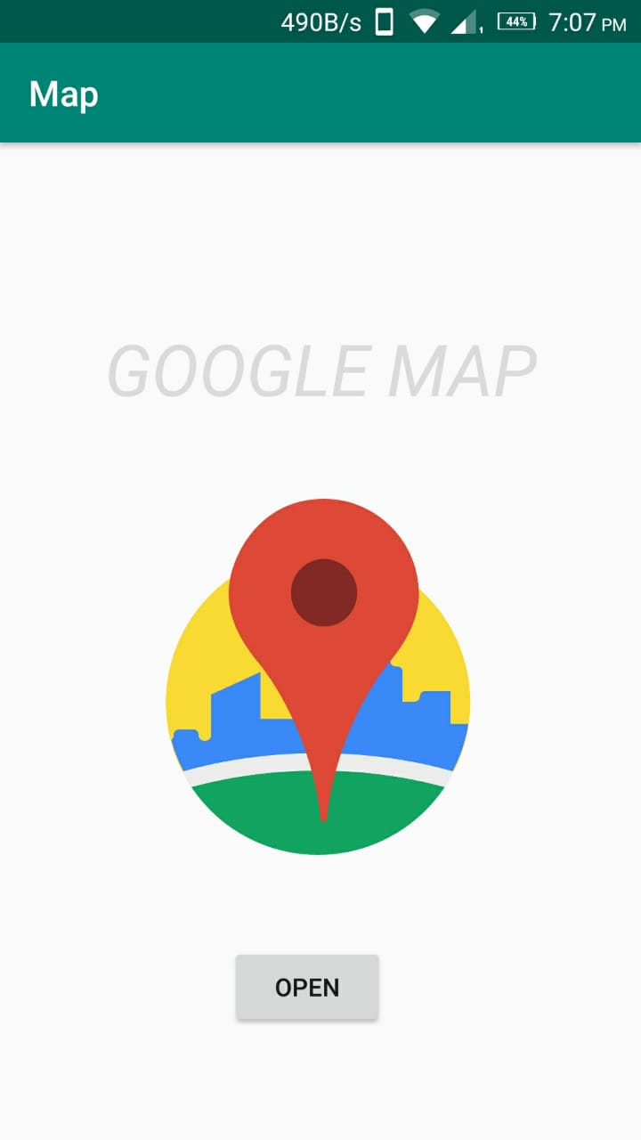

In Fig 3.2.1, this application displays the first layout which is a Relative Layout (activity_maps.xml) with a text and an image on it. The “OPEN” button takes this application to the next layout page as shown in Fig. 3.2.2.

Fig 3.2.2: The second screen design of the proposed system to Search the location.

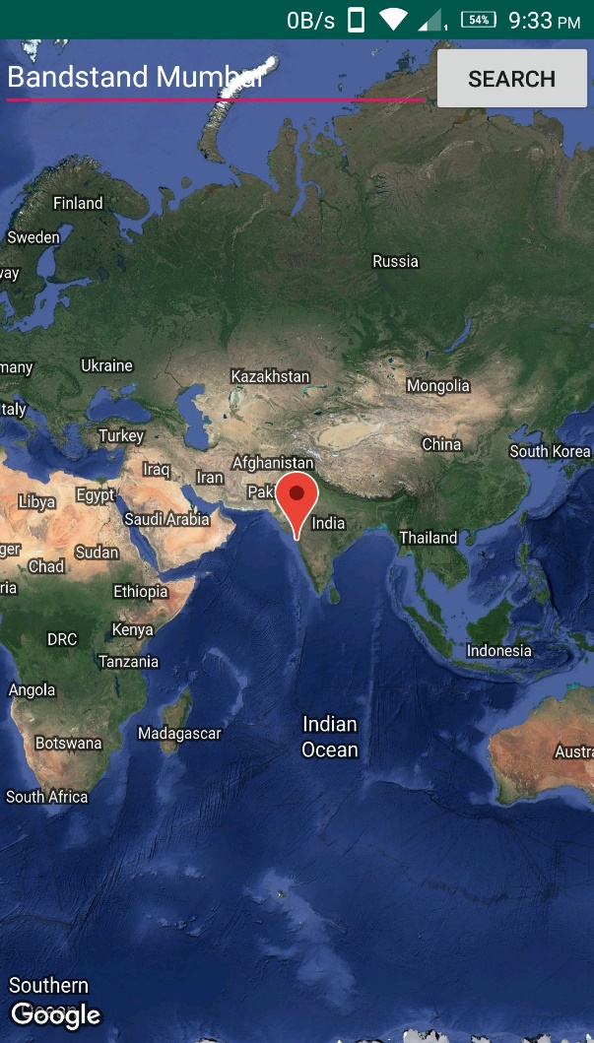

In Fig 3.2.2, the second display layout is a fragment with a Linear Layout file (search.xml) which shows a hybrid map with a Search bar on the top. The location is typed by the user on the Search bar and the “Search” button is clicked to check the typed location.

Fig 3.3.3: Zooms in the searched location on the map.

=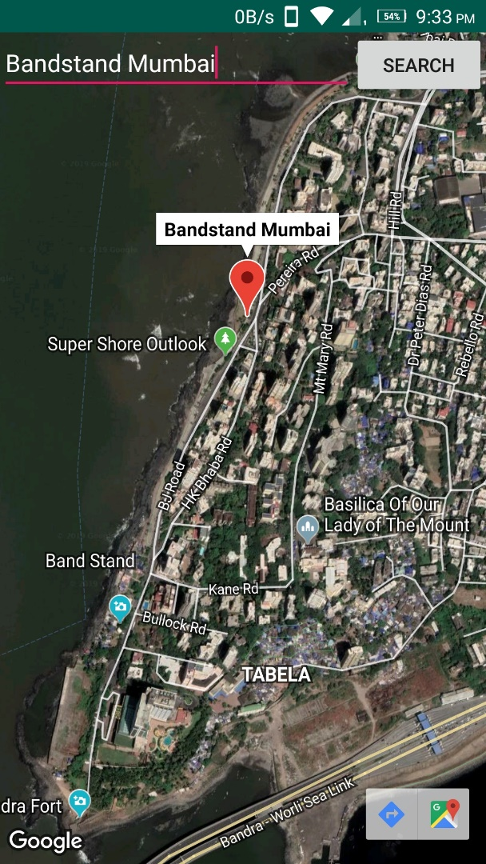

Fig 3.3.3 shows the searched location typed on the Search bar on the hybrid map. Here, ‘Bandstand Mumbai ‘ is typed on the Search bar and the location is automatically zoomed in with the location marked with the marker.

Fig 3.3.4: Another location searched alongside the previous location marked.

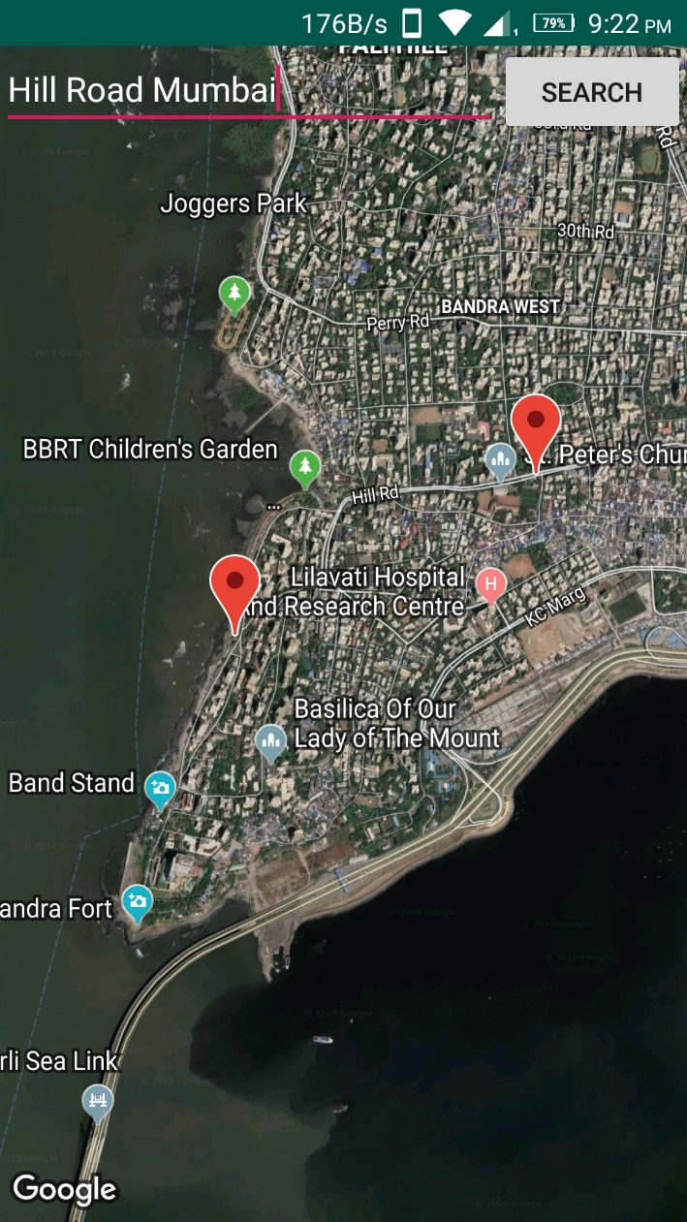

Fig 3.3.4 shows a location typed by the user after searching for the previous location which is marked with the marker alongside the previously searched location. Here, ‘Hill Road Mumbai’ is searched alongside the previous location ‘Bandstand Mumbai’ marked on the map.

4. Hardware software requirements and Implementation

This project has used JetBrains’ IntelliJ IDEA built software: Android Studio, with minimum API level 15: Android 4.0.3 (IceCreamSandwich) with GoogleMaps activity using Java language.

We had to give our application permission to access the mobile devices internet connection (android.permission.INTERNET), (android.permission.ACCESS_FINE_LOCATION), (android.permission.ACCESS_COARSE_LOCATION) and (android.permission.ACCESS_NETWORK_STATE). This permission allows an application to access fine and coarse (e.g. GPS) location (Android 2019).

To access google maps we needed the ‘com.google.android.maps’ library. Classes for the display and control of the map on the user’s device (i.e. moving the map, panning & zooming etc.) were also necessary. A class for getting the devices location and constantly keeping it updated as the device moves was also needed.

We had to write a code **(**mMap.animateCamera(CameraUpdateFactory.*zoomTo*(11));) for the location to be zoomed in automatically after searching for a location by the user.

For Google Maps API key, to run the application we created a credential from the Google Developers Console website (<http://console.developers.google.com>) using the package name and SHA certificate fingerprint and used the API key in the application (google_maps_api.xml).

Result:

We have successfully developed an Android based Application on Location Based Services (Map) where the user can search for any desired location on the map and the location zooms in after the user has clicked the search button to locate his/her desired location on a Satellite Map.

Conclusion:

This application brings out the exact design proposed for the user to search his/her desired location along with displaying nearby places and also searching new location and marking it on the map along with the first location. Thus, the user will be able to get the satellite view of its place of interest by use of this android application on location based map using Location Based Service (LBS).

6. References:

* A model on location based services application development by Leonard Gichuho P58/72874/2009(October2012) <http://erepository.uonbi.ac.ke/bitstream/handle/11295/9166/Gichuho_A%20model%20for%20location%20based%20services%20application%20development.pdf?sequence=1&isAllowed=y>